Government of Andhra Pradesh
Commissionerate of Collegiate Education

Academic & Administrative Audit (AAA)– 2025-2026

FORMAT – I (COLLEGE PROFILE)
PART- A
- Name of the College and Address : S.Y.T.R. Government Degree
College, Near Begarlapalli
Cross, Amarapuram Road,
Madakasira, Sri Satya Sai District,
Andhra Pradesh-515301
URL of Website : www.sytrgdcmadakasira.ac.in
E- Mail : jkc.gdcmadakasira@gmail.com
Phone number : 7780196501

- Vision & Mission :
Vision :- To impart higher education with quality and provide
passport to the students for global citizenship.
Mission :-
- To enlighten the hidden potentiality of the students by elite
teaching
- To reinforce them for expressive
- To inculcate virtues and remind the Motto of the college
“Enter to learn-Leave to serve”
- To dedicate for the societal transformation of knowledge
and wisdom
- To uplift them by thought provoking ideas
- To mold them good citizens to the Nation
- To sanctify them with all concrete measures
- To fill the dynamism and eradicate their weak-spirited.
- Name of the Principal : Dr.G. Sreenivasulu
E-mail :- gajula07@gmail.com and
mobile Number : 7780196501
- Name of the Vice-Principal : Smt.R.Hemalatha,
E-mail :- hemalathahanumanth@gmail.com and
mobile Number : 9492623696
- Name of the IQAC Coordinator : Dr.V.Chandrasekhar Naik
E-mail :- chandu.naik11@gmail.com and
mobile Number : 9618015012

- *Name of the Academic Coordinator (for Autonomous Colleges), email, and mobile Number :- NA
- Year of Establishment :- 1991
- UGC 2(f) and 12 (B) status (certificates to be verified) :- Yes
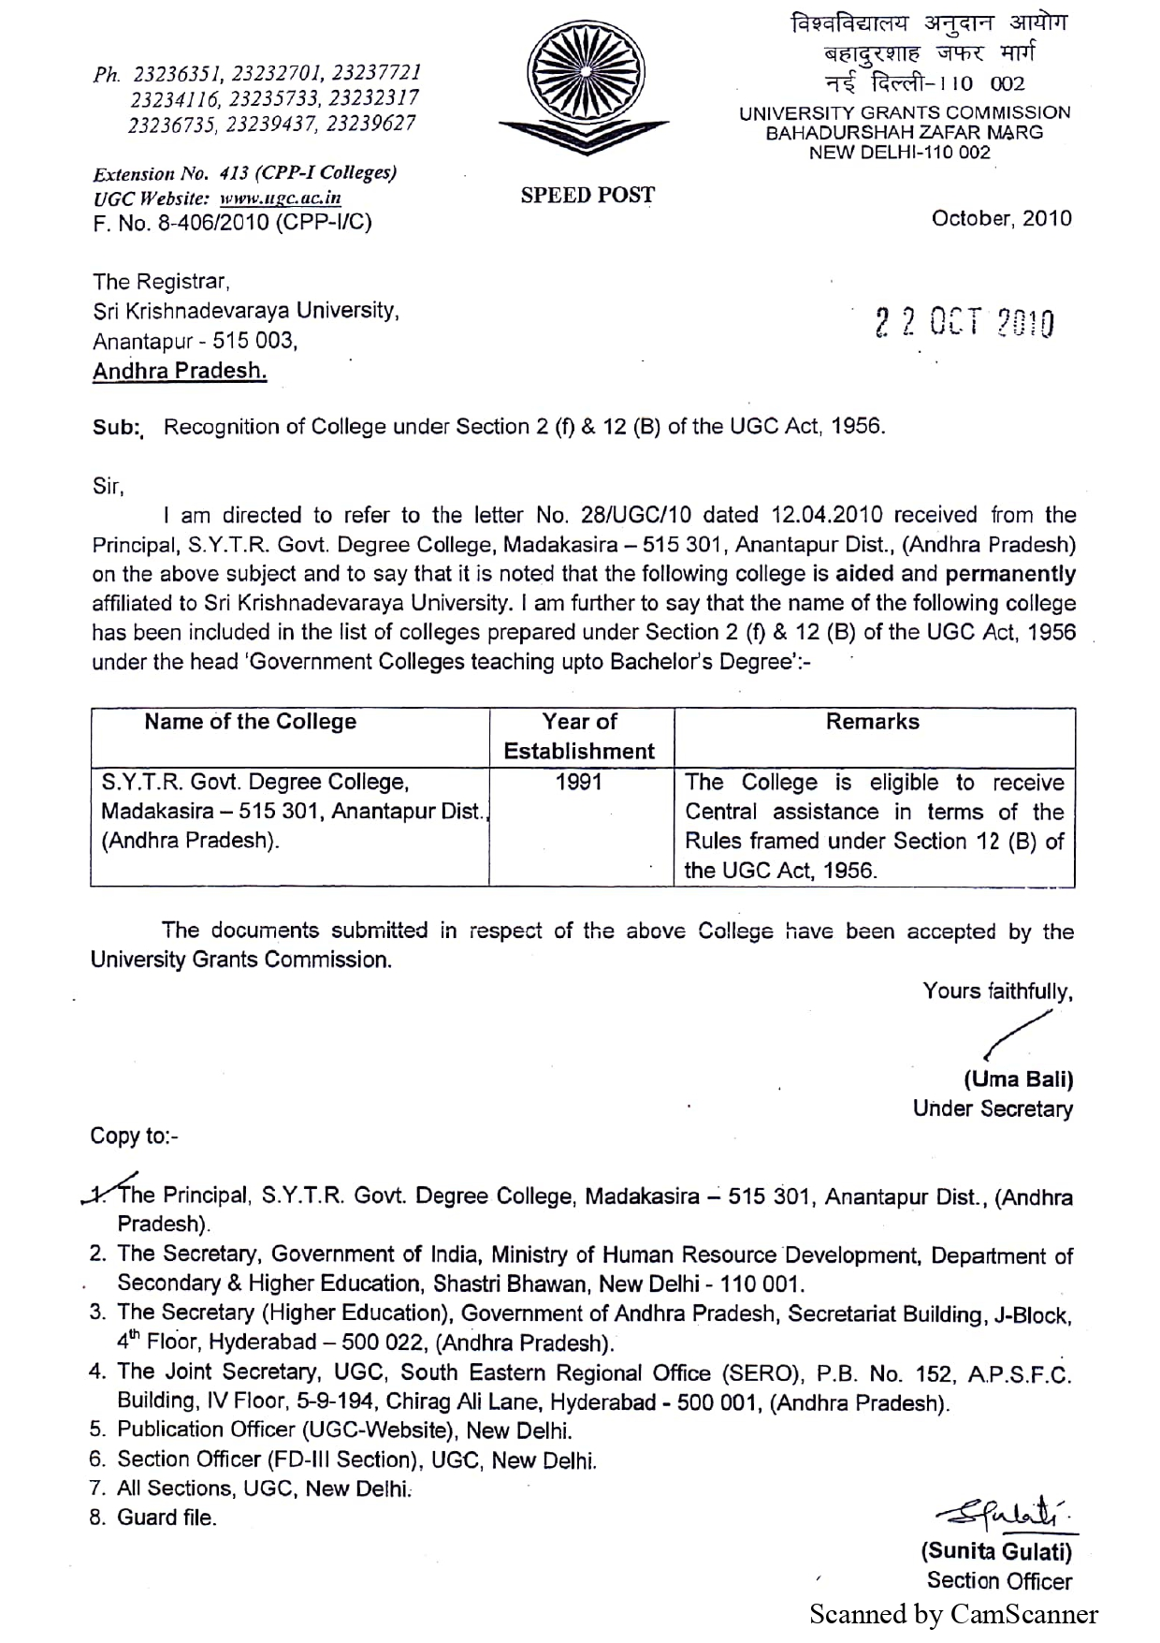

- Autonomous status – Yes/No, If yes, Since, - NO-
- RUSA status :- NO
- College land and Plan details /documents : 8 Acres
- Affiliation status : Permanent / temporary (certificates to be verified)
:- Permanent
- AISHE Status – Document :- Yes
- NAAC Status - Yes
- Previous NAAC Cycle date and Month :- Cycle-1, 15-July-2019
- Date of Expiry :- 14-July-2024
- Previous Grade and CGPA (certificates to be verified):- ‘B’ Grade – 2.27 CGPA
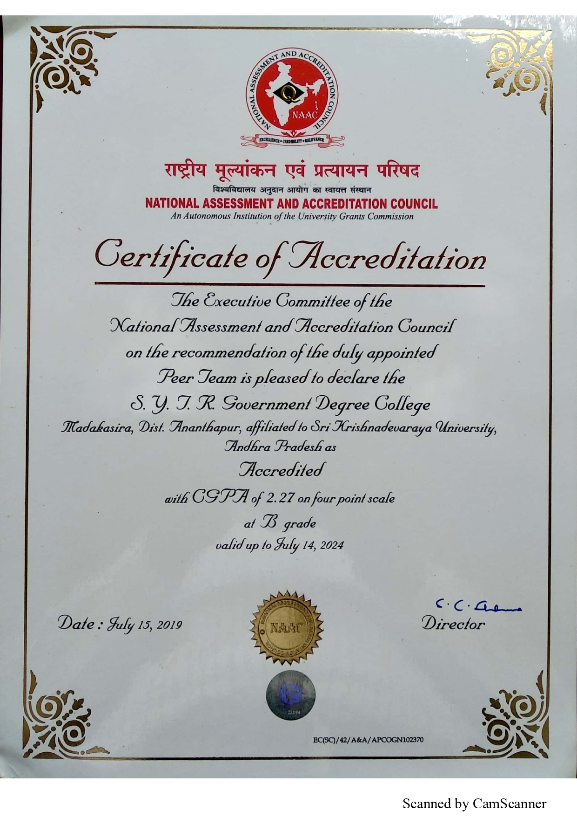
- Status of peer team recommendations
S. No | Recommendations made | Recommendations fulfilled/ To be fulfilled
1 | Infrastructure Improvement | Proposals submitted for Sanction of Sufficient Budget for improving of Infrastructure etc.
2 | ELL and Computer Lab establishment | Proposals submitted for Sanction of Sufficient Budget for establishment of Computer Lab.

Action taken report to be attached
- Previous Recommendations of Academic Audit of the CCE
No. of suggestions made | No of suggestions implemented
12 | 7
Action taken report to be attached
- NIRF Rank (if any) : - Year: - -
- Green Audit Report by Government Agency: -- Year: --
- Awards & Achievements for the institution during the current
Academic Year with details: -
      - Publications – 08 articles, 07 book chapters and 02 Books authored by the faculties.
      - 5 students selected to state level Entrepreneurship & startup boot camp at RTHI, Mangalagiri.

PART-B
- No. of Programmes Offered by the College
Year | 2024-25 | List of Programmes | 2025-26 | List of Programmes
Number of Programmes | 06 | BA- Honors  (Political science)  B.COM- Honors- CA  B.COM- Honors-Accounting  B.SC – Honors-Botany  B.SC- Honors-Zoology  B.SC-Honors-Chemistry | 06 | BA- Honors  (Political science)  B.COM- Honors- CA  B.COM- Honors-Accounting  B.SC – Honors-Botany  B.SC- Honors-Zoology  B.SC-Honors-Chemistry

- No of Value Added Courses introduced (last two years)
Year | 2024-25 | List of Courses | 2025-26 | List of Courses
Value Added courses | 0 | 0 | 0 | 0

- Details of teaching faculty
No of posts | Sanctioned | Working | Vacancies
Regular | 24 | 07 | 04
PTL |  | 0 | 0
Contract |  | 09 | 0
Guest |  | 04 | 0
Total |  | 20 | 04
- Qualifications of teaching staff
Teaching Staff | PG | M. Phil | Ph.D | NET/SET
Regular | 07 | 2 | 06 | 3
PTL | 00 | 00 | 00 | 00
Contract | 09 | 04 | 03 | 01
Guest | 4 | 0 | 0 | 0
Total | 20 | 06 | 9 | 4
- Details of non- teaching faculty
No of posts | Sanctioned | Working | Vacancies
 | 9 | 4 | 5
Total | 9 | 4 | 5
- Student strength particulars
- During the last two years
Year | 2024-25 |  |  |  | 2025-26
No. of students | I | II | III | I |  | II | III
No. of students | 167 | 132 | 148 | 174 |  | 167 | 132

- No of students appeared in the final year exams during the last two years

Year | 2024-25 |  |  | 2025-26
Programme wise | A | P | % | A | P | %
Programme wise | 117 | 103 | 88 | 81
B.A | 49 | 42 | 85 | 16
B.Sc | 31 | 28 | 90 | 32
B.Com | 37 | 33 | 89 | 33
- Teacher – student ratio (Current Year) : 1: 24
- Infrastructure details (Physical and Academic facilities of Criterion-IV)
- Total no of class rooms : 10
- Total no of laboratories : 04
- Total no of digital classrooms : 01
- Total no of virtual classrooms : 01
- Total no of ICT enabled classrooms : 01
- Total no of studios : 00
- Total no of Computers, Student & Computers Ratio : 37 , 1 : 25
- Total no of printers : 10
- Total no of scanners : 04
- Total no of Xerox facility (at Depts & Office) : 01
- Total no of Wi-Fi routers : 04
- Internet Bandwidth : 300 Mbps & 100 Mbps
- Seminar halls : 01
- Auditorium : 01
- Details of sports facilities : Play ground available
- Gymnasium (No of stations) : --
- Rooms for administration : 01
- Water – RO facility : 01
- Toilets for staff (Men/Women/Differently abled) : 02 (Men:01 & Women : 01, Differently abled : 0)
- Toilets for students (Men/Women/Differently abled) : : 02 (Men:01 & Women : 01, Differently abled : 0)
- Divyangan friendly facilities (Ramps/Lifts/Softwares) : 01 Ramp available
- No of fire extinguishers in the labs and corridors : 00
- Solar energy details – LEDs , Green Audit Status : 01 Solar, plank
- Examination Cell : Yes
- Library : Yes
- No. of Books & Journals : 2696 Books & 05 Journals
- Status of Automation : No automation
- E-journals : - -
- Nlist subscription : - -
- Internet : Yes, available
- Foot Fall : - -
- E-footfall : - -
- Xerox Facility (at Library) : - -
- Women’s waiting hall : Yes, Available
- Grievance Reddressal Cell : Yes, Available
- Health Centre : NO
- ELL : Yes, Available
- JKC Lab : NO
- Computer Labs : 01
- Canteen Facility : NO

10. Research :
- No of collaborations / Functional MoUs
Year | 2024-25 | 2025-26
Number of collaborations / MoUs | 0 | 0
No. of Follow up Activities | 0 | 0

- No of publications in UGC – CARE listed journals
Year | 2024-25 | 2025-26
Number of Publications | 0 | 8+7+2  (08 articles, 07 book chapters and 02 Books authored by the faculties)

- No of start-ups
Year | 2024-25 | 2025-26
Number of start-ups | 0 | 0

- No of patents
Year | 2024-25 | 2025-26
Number of patents | 0 | 0

- No of Research Guides
Year | 2024-25 | 2025-26
Number of Research Guides | 0 | 0

- No of Research Scholars
Year | 2024-25 | 2025-26
Number of Research Scholars | 0 | 0

- No of Major/ Minor Research Projects
Year | 2024-25 | 2025-26
Number of Major RPs | 0 | 0
Number of Minor RPs | 0 | 0

- Incubation Centre with Research Facility: Yes/No : No
- Consultancy offered: NO
Area | Organization (MoU) | Revenue Generated
- | - | -

- Policies prepared and implemented (Give Details): -
- No. of Committees appointed (Provide links of meeting minutes & reports) - 18
- Extension activities (Current year )
- No. of Extension activities in the Neighborhood for social and holistic development

- No of Extension activities conducted through NSS/NCC/ RED CROSS/YRC : 62
- No of Extension activities in collaboration with government agencies: 0
- No of Extension activities in collaboration with Non-Governmental Organizations: 01

- Feedback, Student Satisfaction Survey mechanism adopted : (Provide Link)
- Alumni Association – involvement and activities :
No. of meetings conducted :
- Awards and achievements-current year (to be verified - )

- Students : - 5 students selected to state level Entrepreneurship &
startup boot camp at RTHI, Mangalagiri.
- Staff : 08 articles, 03 book chapters and 02 Books authored
by the faculties.
- Total no of scholarships and free ships (Current Year) 527
Total Amount in Rs:- 1,59,695/-
- Total no of capacity building and skill development activities conducted by the college (Current Year)

Teaching | 2 Online Training programs on Artificial Intelligence
Non –Teaching | 0
- Trainings conducted by JKC for competitive exams during the last two years
Training:
Year | 2024-25 | 2025-26
Number of students registered | 50 | 55
Number of students trained | 50 | 55
a. from your GDC | 50 | 55
b. from other colleges | 00 | 00
Placements:
Year | 2024-25 | 2025-26
No. of companies visited the campus | 02 | -
Number of students Placed | 18 | -
a. from your GDC | 18 | -
b. from other colleges | 00 | -
Note:-The Financial year students are undergoing internship

CSP:
Year | 2024-25 | 2025-26
Number of students Participated in CSP | 121 | -
- B.A | 26 | -
- B.Com | 53 | -
- B.Sc | 42 | -

Note:- 2025-26 first year students are in second semester
Internship:
Year | 2024-25 | 2025-26
Number of students completed Internship | 89 | 82
- B.A | 23 | 17
- B.Com | 52 | 33
- B.Sc | 16 | 32

Type of Internships:
Year | 2024-25 | 2025-26
Total No of Physical Internships | 00 | 00
Total No of Online Internships | 89 | 82
Total No of paid Internships | 00 | 00
- Student Support and Progression

- Students Progression to Higher Education (Programme wise)
Year | 2024-25 | 2025-26
Number of students | 17 | 13
- B.A | 2 | 2
- B.Com | 8 | 5
- B.Sc | 7 | 6
- Employment (Programme wise)

Year | 2024-25 | 2025-26
Number of students | 18 | -
- B.A | 3 | -
- B.Com | 12 | -
- B.Sc | 3 | -
- Entrepreneurship (Programme wise)
Year | 2024-25 | 2025-26
Number of students | 0 | 5
- B.A | 0 | 0
- B.Com | 0 | 3
- B.Sc | 0 | 2
- Grants/funds received from (in Lakhs/Rs.)
- Government : Rs.17000/-
- Non-governmental bodies : ---
- Individuals/ Philanthropists : ---
- CSR : 300 plastic chairs, 02 Tea pie, Podium and projector supplied by the Transactions Analysts India Private Limited, Bangalore.
- Budget allocated for Infrastructure : ---
- Expenditure for Books & Journals
Budget Sanctioned Rs. 00 ; Utilized Rs. 00
- Governance and Leadership
- Institutional Development Plan (Next two years)
- Institutional distinctiveness in specified area
- Contribution of IQAC
- Incremental changes during the last two years

- Best Practices of Institution
1. Blood Donation Camp
2. Green Campus
- Evaluative Reports of the Departments (Provide Links)

- For Autonomous Colleges

- Academic Council
- Last Academic Council meeting date
- Major decisions for enriching curriculum/Academics
- Controller of Examinations
- Examination reforms proposed and implemented
- CIA
- Mechanism for addressing grievances
- Mechanism for transparency in setting up of Question papers
- Mechanism for appointing examiners
- Mechanism adopted to ensure the security of information
- CoE expenditure report with details

- Board of Studies
- Mechanisms for updating curriculum
- Justification Reports for Curricular revamp
- Governing Body
- Last G.B meeting date
- Major resolutions for administration
- College Handbook (to be uploaded on the college website)
- College Magazine (to be uploaded on the college website)
- Monthly News Letters(to be uploaded on the college website)
- Departmental meeting Minutes Registers (to be verified)
- Reports of various committees (to be verified)
- CPDC/Finance Committee Meeting Minutes Registers (to be verified)
- Implementation status of Biometric Attendance and TLP Reports (to be verified)

